**Total order amount**

**SCENARIO:** Total order amount per customer if they have multiple orders - in a mapper.

**ACTIVITIES: 1.Read File**

**2.ParseData**

**3.Mapper**

**4.Timer**

**TIMER:**

**Timer is a process starter activity that starts the process at a specific time. You can also specify the processes to be started periodically.**

**PARSE DATA:**

**Parsedata takes CSV data as a input and it is gives output as XSD tree base specified XSD data.**

**MAPPER:**

**Mapper activity that adds a new process variable to the process. This variable can be an inline schema, primitive element, or a complex element. You can map the data values from the current list of process variables to the elements of the variable with the Mapper activity.**

**PROCEDURE:**

**1.Take activities in tibco bw6.x work bench/studio canvas as same pattren as below.**

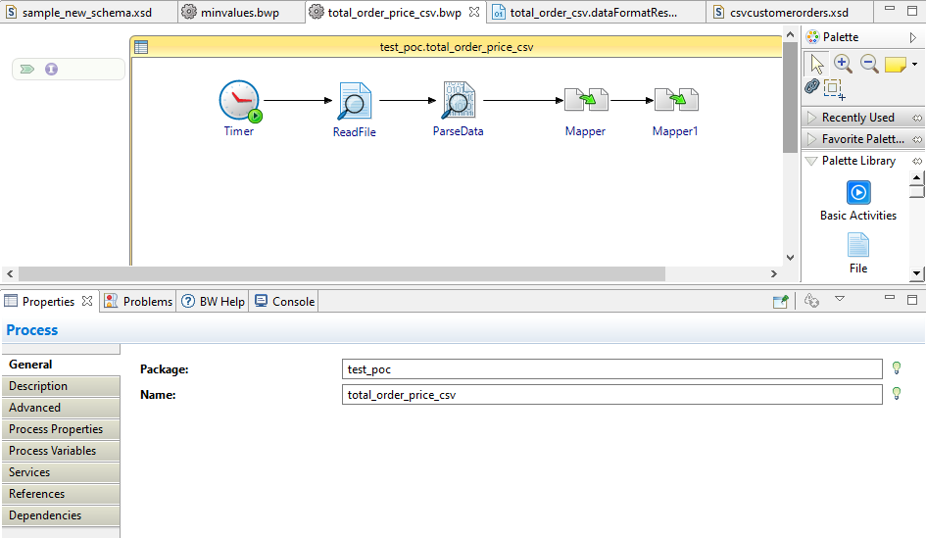

1. **Configure input csv file into read file in the general tab**

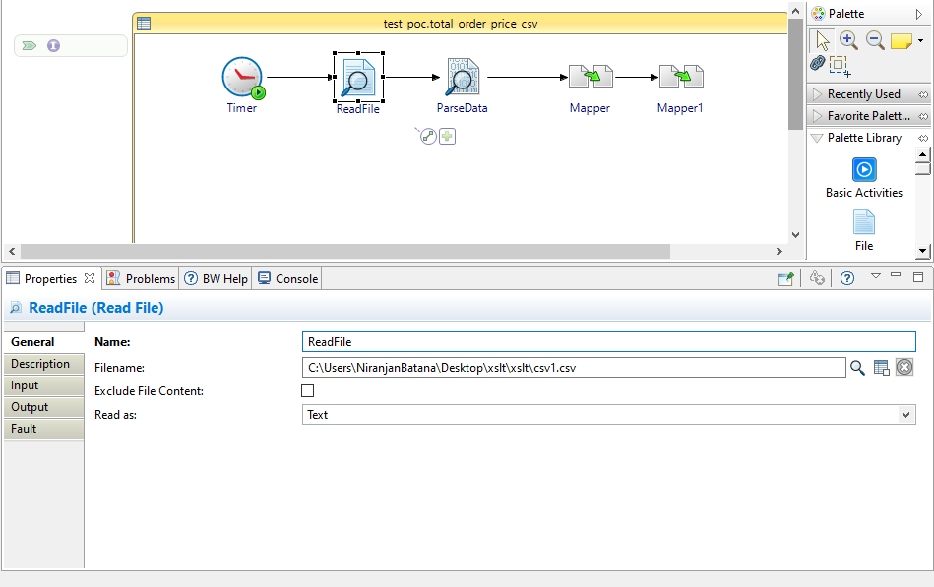

1. **Give input of parsexml as coming read file output and configure data formate in general tab and give the data formate schema as below.**

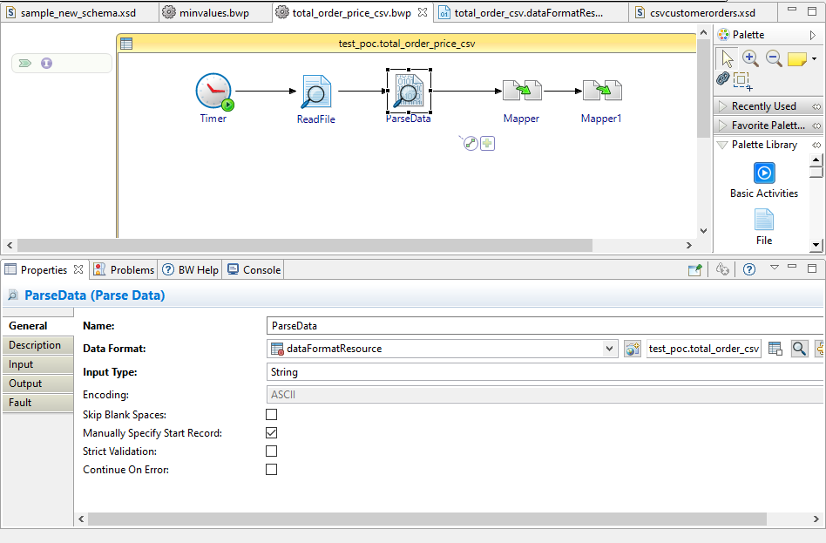

**Data formate schema**

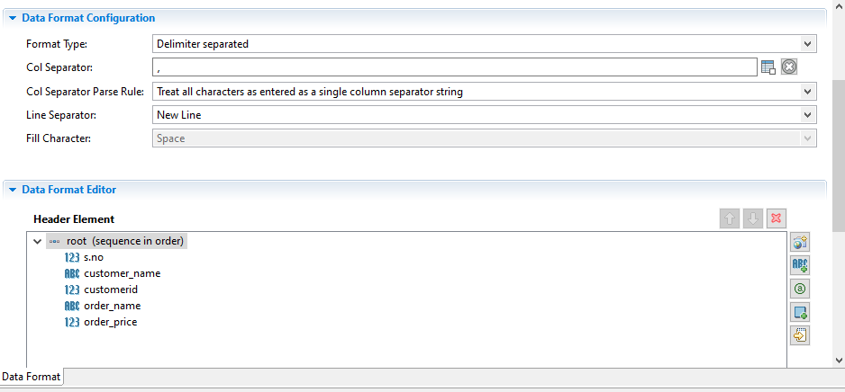

**Give the mapper input schema in put editor as below.**

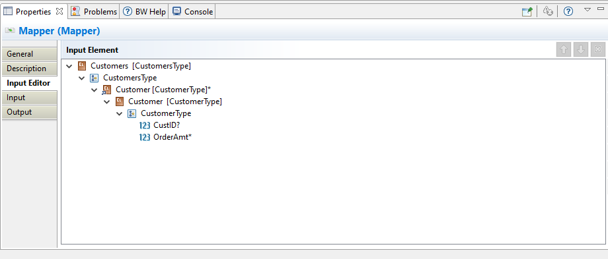

**Give the input mapping as below**

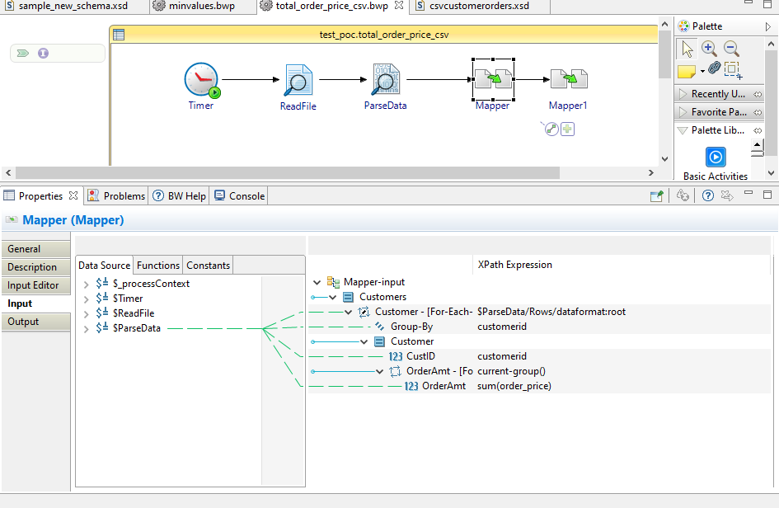

**Mapper1 map inputs as below**

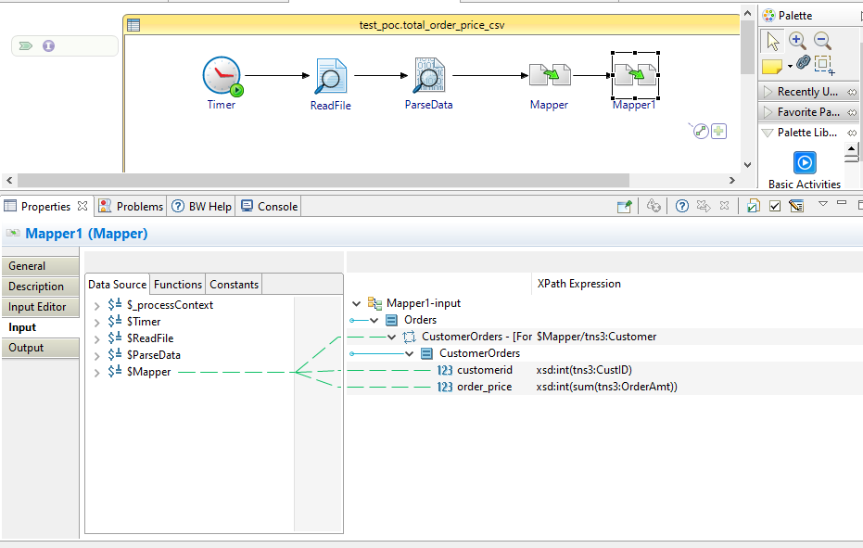

**Output will be as below**

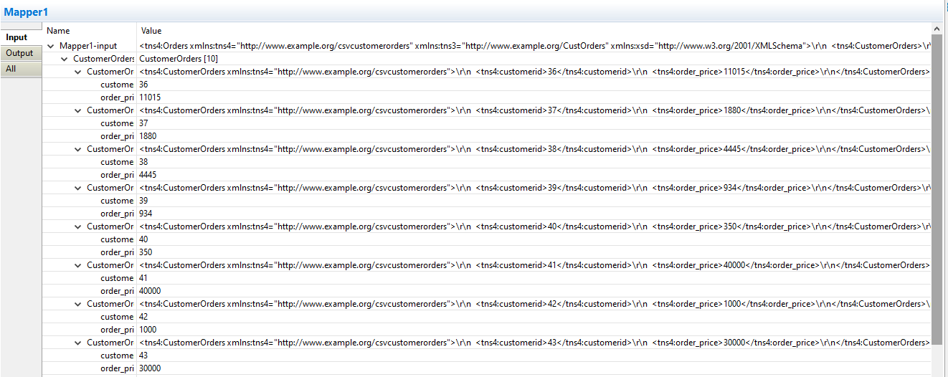



**Input file snap**

